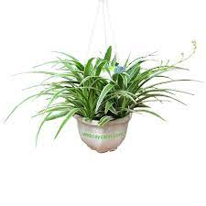

Scientific name: Spider Plant, **Chlorophytum bichetii** (cỏ lan chi)

**LIGHT:**

.Outdoors, spider plants prefer to grow in light shade. They can tolerate heavy shade, but their growth won't be as robust. Direct sunlight can scorch the leaves. Indoors, a bright window or patio door that gets indirect sun is ideal.

.

**WATERING:**

Spider plants like lightly moist but not soggy soil. Overwatering can cause root rot and ultimately kill the plant. These plants are sensitive to fluoride and chlorine in water, which can brown the leaf tips.So if possible, use rainwater or distilled water for container plants

**SOIL:**

These plants can grow in a variety of soil types, but they favor loose, [loamy soil](https://www.thespruce.com/loamy-soils-why-gardeners-love-them-2131083) with sharp drainage. Spider plant prefers a fairly neutral soil pH but can tolerate slightly acidic to slightly alkaline soil. A high level of salts in the soil can cause the [leaf tips to turn brown](https://www.thespruce.com/reasons-your-spider-plant-has-brown-leaf-tips-7481362).

**FERTILIZING:**

These plants like a moderate amount of feeding, roughly once a month during the active growing seasons of spring and summer. Too much fertilizer can cause brown leaf tips, but too little fertilizer will result in weak growth.1

Use an all-purpose granular or water-soluble fertilizer during the growing season, following label instructions. Adjust the amount if necessary depending on your plant's growth.

**Temperature and Humidity:**

Warm, humid conditions are ideal for spider plants. They don’t like temperatures below 50 degrees Fahrenheit. This means they should be protected from drafts and air-conditioning vents when grown indoors. Moreover, the leaf tips can brown if the humidity is too low